ARMY GOODWILL PUBLIC SCHOOL RAJOURI
WORKSHEET ON MATRICES
CLASS -XI - SCIENCE- MATHS

- A square matrix A is called idempotent if
  - A² = I
  - A² = O
  - 2A=I
  - A² = A
- Let for any matrix M ,M⁻¹ exist. Which of the following is not true.
  - none of these
  - (M⁻¹)⁻¹ = M
  - (M⁻¹)² = (M²)⁻¹
  - (M⁻¹)⁻¹ = (M⁻¹)¹
- The system of equations x + 2y = 11, -2 x – 4y = 22 has
  - only one solution
  - infinitely many solutions
  - finitely many solutions
  - no solution
- Sum of two skew-symmetric matrices is always ________ matrix.
- ________ matrix is both symmetric and skew-symmetric matrix.
- If A and B are square matrices of the same order, then (kA)’ = ________ where k is any scalar.
- The no. of all possible matrics of order 3 ×× 3 with each entry as 0 or 1 is-
- If A is a square matrix, such that A² = A, then (I + A)³ – 7A is equal to
- If a matrix has 28 elements, what are the possible orders it can have? What if it has 13 elements?
- Construct a2 x 2 matrix, where:
(i)a_{ij} = (i-2j)² / 2 (ii) a_{ij} = |-2i+3j|
11. - If possible, find the sum of the matrices A and B, where
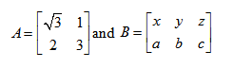

12. Find the values of a and b, if A = B, where
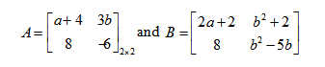
13. Express the given matrix as the sum of a symmetric and a skew-symmetric matrix.
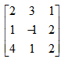

14. If possible, using elementary row transformations, find the inverse of the following matrices.
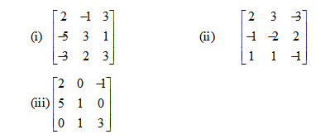
15.Find a matrix C such that 3A + 5B + 2C is a null matrix, where:
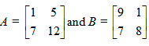
16. Find the matrix A satisfying the matrix equation given below:
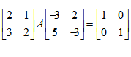
17. If a matrix have 5 elements, write all the possible order to can have.
18.Is matrix multiplication is commutative, state true or false.
19. The negative of matrix is obtained by multiplying the matrix by.......
20. The diagonal element of skew symmetric matrix is.......

